|  |  |
| --- | --- |
|  | **Annual Report 2021** |





|  |  |
| --- | --- |
| **Our vision**  **is a world of peace, social justice and sustainable development, where all people live together with mutual respect.** | **Our mission**  is to promote a culture of peace, social justice and sustainable development by organizing and supporting volunteering projects, both in Ireland and internationally. |

|  |  |
| --- | --- |
| **Our mission**  **is to promote a culture of peace, social justice and sustainable development by organizing and supporting volunteering projects, both in Ireland and internationally.** | **Our mission**  is to promote a culture of peace, social justice and sustainable development by organizing and supporting volunteering projects, both in Ireland and internationally. |

**Voluntary Service International**

**SEIRBHIS DEONACH IDIRNAISIUNTA CUIDEACHTA FAOI THEORAINNRÁTHAÍOCHTA**

Carmichael House, 4 Brunswick Street North, Dublin, D07 RHA8, Ireland

***Local and global volunteering for peace***

|  |
| --- |
| **Contents**   1. **About VSI** 2. **Introduction** 3. **Volunteer Projects**    * **International Volunteer Projects**    * **European Solidarity Corps**    * **Volunteers in 2021** 4. **Volunteer Experiences** 5. **The Dublin Local Group** 6. **Youth Voices Online** 7. **Youth for Climate Justice** 8. **Networking and collaboration**    * **Service Civil International**    * **Networks in Ireland**    * **Staff collaboration with Partners** 9. **Governance** 10. **Staff Team** 11. **Funding and Finances** 12. **Staffing**   **Get involved in VSI**  **Annexes**   1. **VSI Strategic Plan, 2021-2025** 2. **VSI Financial Statements, 2021** |



VSI is the Irish branch of Service Civil International (SCI), a worldwide peace movement that began life after the First World War. We are a volunteer-based movement founded in 1965 and headquartered in Dublin.

1. **Voluntary Service International**

**For over 56 years** we have promoted peace, social justice and sustainable development at home and abroad. During that time walls have fallen, borders have moved and the challenges facing us have changed. While many things have undoubtedly improved, there are still many of the old problems (e.g. conflict, human rights) alongside the emergence of new problems (e.g. climate change, growing inequality).

**These challenges** are large and multifaceted but we at VSI believe we can play a part in addressing them. At the heart of many of these problems is a lack of understanding. Of people, their backgrounds, their cultures, their own day-to-day challenges. Of the environment, its importance, its fragility, our impact on it. And the interdependence of all of these things.

**The tool we have chosen** to help combat this is a simple one, but we know through experience that it is a powerful one: volunteering. By bringing together volunteers from across the globe we aim to increase awareness and understanding of the people, the societies and the environment around us. This deeper understanding will contribute to a global and local society which is more open-minded, aware and responsible for its own behaviour and actions. We are able to do this with the help of our network partner organisations at home and abroad, enabling volunteering experiences that promote peace, social justice and sustainable development.

**In 56 years, we have achieved a lot as an organisation**. We recognise that over this time the world has changed and that we, as VSI, need to adapt to this and the new challenges it presents. Our new strategic plan1 represents our vision and intent for how we will rise to meet those challenges.

**Voluntary Service International (VSI) is** a limited company having no share capital.

**Company number:** 40520; **Registered** **Charity Number:** 20023065; **CHY (Revenue) Number:** 9220

**oUR vALUES**

2021 was another challenging year for VSI and our international organisation SCI (Service Civil International).

1. **Introduction**

Our work centres on personal contact so the pandemic and lockdown brought out the creativity, resourcefulness and ability for hard work in staff, Board and volunteers.

We developed new forms of online volunteering and educational link-ups and used the opportunity to develop a new Strategic Plan and review our activities, plans and governance.

The staff team, led by CEO Helen Walmsley adapted to new ways of working.

Mateja Jakšić, the as Volunteer Programme Coordinator who helped Helen develop VSI through times of change in the operating environment moved on to a new job in the National Youth Council of Ireland. We had a chance to thank her for her work and enthusiasm. And she continues to help VSI as a volunteer.

Helen and Mateja were very ably supported by Maria Conte (Communications and Marketing) and Aine Boyle (Programmes) as one-year volunteers under the European Solidarity Corps (ESC) until November 2021. Aine was then recruited as Programmes Officer, to replace Mateja. Two new ESC volunteers started in November, Eiméar Savage (Programmes) and Nicolas de Wergifosse (Communications and Marketing).

Our Dublin Local Group volunteers maintained the suspension of their work in 2021 due to the ongoing COVID-19 restrictions. DLG volunteers reviewed their protocols and guidelines and kept in touch with each other regularly online and held virtual social activities**.**

I would also like to thank the Board members for a very active year’s work. Jason Campbell, Chairperson, and Ian Carter resigned at the start of the year. Liam Keenan, Pearl Clarke, Máille Brady Bates, Claire Devlin and Dervla King continued through the year and I was appointed Chairperson in January.

In 2021 we held our second online AGM. We are pleased to have continued working with our auditors Roberts Nathan.

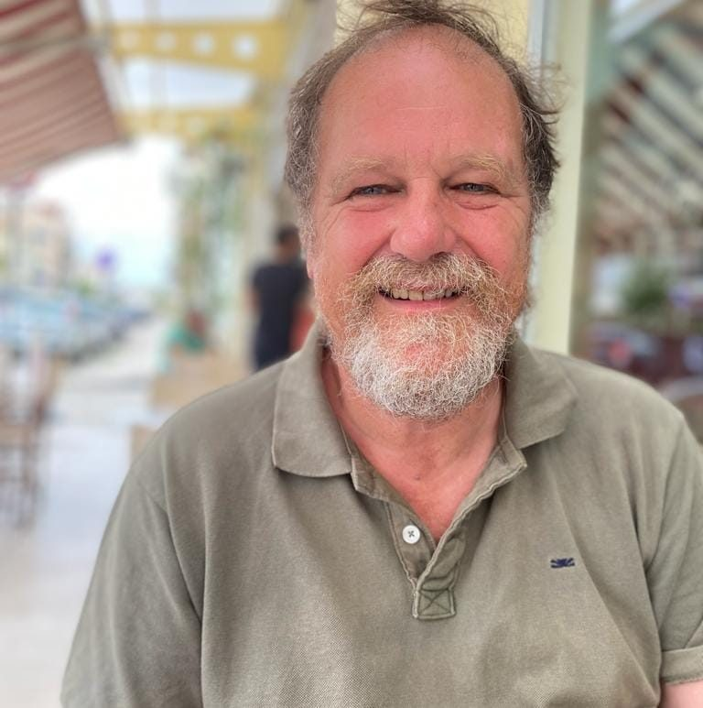VSI’s work would not have been possible without the support of funders and donors. Our principal sources of funding were the Youth Service Grant, Youth Capital Funding, Youth Climate Justice Fund and COVID-19 Minor Grant Schemes of the Department of Children, Equality, Disability, Integration and Youth (DCEDIY) and the European Commission (through the European Solidarity Corps (ESC) programme, administered by Leargas). We also received a grant from the Health Service Executive. In 2021 we received project and membership fees and generous donations from volunteers and donors.

We are grateful for the support from DCEDIY as part of the Shared Services Support in accounts and governance delivered through Bradan accounts and The Wheel, coordinated by NYCI.

Finally, I would like to personally thank the volunteers who are the lifeblood of VSI for their work at every level, including projects in Ireland, internationally and online.

**Robin Hanan, Chairperson**

**3. Volunteer Projects**

**International Volunteer Projects move online**

International Volunteer Projects (IVPs) are a unique form of volunteering, which bring together people from different countries, cultures and backgrounds to live and work together on short-term projects with local communities in over 70 countries worldwide. Volunteers support these communities in their long-term work for a more just, environmentally friendly and peaceful society.

The projects also aim to develop the intercultural understanding of volunteers, who learn about the cultures of volunteers in the group through discussion, themed free-time activities and cooking together.

The ongoing pandemic and restrictions meant that our in-person International Volunteer Programmes remained suspended for the duration of 2021. We based this decision on the health, safety and security of our volunteers, partners and staff. The one exception is …

**In-person International Volunteer Programme and 90th anniversary of IVS (UK), Strangford**

We were able to hold one in-person International Volunteer Programme with our long-term partner, Glebe House in Strangford in Northern Ireland in a window of opportunity in September, when COVID-19 restrictions were lifted for a period.

**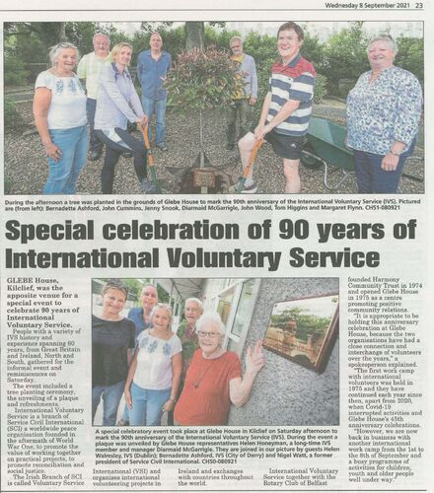**From 1 - 8 September Glebe House and VSI organised our first in-person IVP in Ireland since September 2019, involving 5 VSI volunteers from Ireland. The work of the volunteers included painting play structures in the grounds, cleaning out the garden pond, tidying up in the garden and grounds around Glebe House. A big part of the week were the 90th anniversary celebrations of our branches ‘International Voluntary Service’ in Northern Ireland (now closed) and Britain. Glebe held a special event on Saturday 4th September to mark the occasion, we heard talks from Glebe House volunteers, staff and board members and Helen Walmsley, VSI’s CEO who joined in the celebrations. It was lovely to see familiar faces and meet up with old IVS friends and exchange stories about volunteering experiences over the years. The special event included the planting of a beautiful "Red Robin" tree in the Sensory Garden and the unveiling of a plaque.

***Volunteer Projects (continued)***

In 2020, the SCI (Service Civil International) community of which we are a part quickly adapted to the ‘new normal’ and began offering online projects. VSI volunteers continued to engage in this form of volunteering throughout 2021, with 25 VSI volunteers joining online IVPs. Project topics ranged from environmental sustainability to women’s suffrage to the history of SCI and the peace movement. These projects were organised by various SCI branches and partners, including SCI Switzerland, SCI Germany, and SEEDS Iceland.

Online IVPs have allowed volunteers to continue to connect with people from different places and cultures. Online volunteers work together virtually for peace and social justice, and enjoy a strong focus on non-formal learning through groupwork, discussions and presentations.

**European Solidarity Corps**

VSI have both coordinated and partnered in European Solidarity Corps (ESC) – formerly European Voluntary Service (EVS) - projects by sending and hosting volunteers abroad and in Ireland.

This EU-funded volunteer programme is open to 18-30 year olds, and provides young people with opportunities to get involved in the work of a wide variety of non-governmental, not-for-profit organisations, either abroad or in their home country, for between 2 and 12 months.

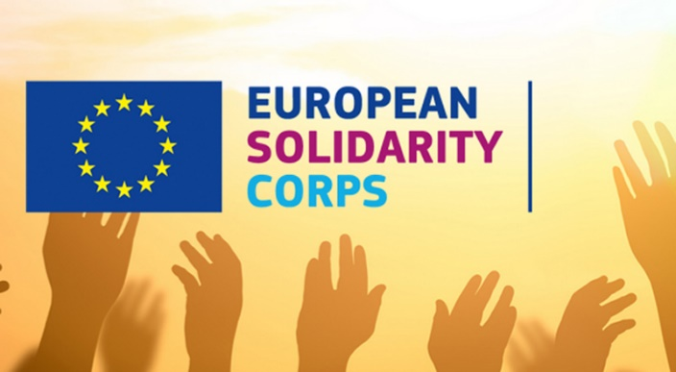The programme is fully funded, with volunteers’ living allowance and accommodation, travel costs, insurance and language training all covered. Projects are on a range of themes and topics including community and youth work, human rights, social inclusion, theatre, multimedia, environmental protection, sustainability, and many more. Through civic engagement, the programme aims to foster a sense of community and intercultural understanding among young people across the EU and beyond.

VSI welcomed two new in-country ESC volunteers to the office in October 2021, to continue the work of the previous two in-office volunteers who began in November 2020. Their activities are outlined below, along with the experiences of a number of ESC volunteers whom VSI sent on projects across the EU in 2021.

**15,000 volunteering hours by VSI volunteers in 2021!**

**Thankyou everyone!**

***Volunteer Projects (continued)***

**VSI Volunteers in 2021**

|  |  |
| --- | --- |
| **International Volunteer Projects**  **(mostly on-line)**  **Who were they?**  8 were between 18 and 24  17 were over 25  3 men  22 women  **Where were they based?**  2 in Switzerland  7 in Germany  16 in Iceland  **What were the themes of the projects?**  16 Environmental Protection  1 Women’s Suffrage  1 SCI and the peace movement  1 Commemoration of forced labour victims    **A protest ESC volunteer Jessica attended with her host organisation against the Asylum reception crisis in Belgium** | **European Solidarity Corps**  **(mostly longer term)**  **Who were they?**  9 were 18-25 years old  6 were over 25 years  5 men  10 women  **Where were they based?**  2 in Italy  1 in Sweden  3 in France  1 in Greece  1 in Belgium  1 in Germany  2 in Portugal  1 in Poland  1 in Luxembourg  1 in Czech Republic  1 in Austria  **What were the themes of the projects?**   * Environmental protection * Integration of migrants and asylum seekers * Community & youth work * Culture & heritage * Human rights/inclusion * Education   **How long did they serve?**  2 served for 2 months  1 for 5 months  1 for 7 months  3 for 9 months  1 for 10 months  3 for 11 months  5 for 12 months  **That’s 146 months (12 years) in total**  **(plus our four office volunteers described below!)** |

**International Volunteer Projects online**

**4. Volunteer experiences**

|  |
| --- |
| **Environmentally Aware online project**  **VSI volunteer Holly Power**, who participated in the ‘Environmentally Aware’ online IVP with SEEDS Iceland, says:  “*I have a real grá for all things sustainable and was really happy to see that I could still take part in volunteer work even during the pandemic, learning from home. Usually, the projects are held in person in Iceland but even though the projects are online for the time being, I didn’t feel like I was missing out, and after three hours a day meeting my fellow participants and camp leaders, I truly came away from it more knowledgeable and optimistic, and it filled my day with many happy hours with researching, sharing and learning all about sustainability and climate action.*  “*The project superseded all of my expectations and I made amazing connections and met people from all over the word. We had participants from Colombia, Suriname, Brazil, Ireland, Slovakia, the Czech Republic, Turkey and Kazakhstan and we had an amazing time getting to share our ideas and experiences and I came away from the project with a warm feeling in my heart, a great appreciation for our little community and together sharing a collective appreciation and passion for sustainability and ecology.*  “*Our project leaders Julcsi from Hungary, and Clarisse from France, were amazing and engaging and were incredible in bringing this message to us and somehow made us laugh constantly throughout. We broke the ice with virtual drawing games, baked bread and cooked vegetarian fake meat together, shared our ideas, learnt about environmental issues and talked about possible solutions. We learned about how to reuse everyday plastic or non-recyclable items for a second purpose and broadened our minds about how we can implement these initiatives in our home countries. We watched interesting documentaries and got to know and appreciate each other’s cultures and languages, and then finally took part in relaxation, meditation and yoga sessions to wind down.*  *“I thoroughly enjoyed my time as part of the SEEDS Iceland virtual project and I believe it’s a great way of learning more about how we can help the environment in a fun and engaging way.”*    ***VSI volunteers Holly, Janet, and Natalia showing off their repurposed plastic bottles during the ‘Environmentally Aware’ IVP*** |

***Volunteer Experiences (continued)***

|  |
| --- |
| **Wikipedia for Peace – Women’s Suffrage project**  **Anna,** online volunteer on SCI Switzerland’s ‘Wikipedia for Peace: Women’s Suffrage’, says:  *“The Wikipedia for Peace: Women’s Suffrage programme made me aware of the gender disparity that exists on Wikipedia. Not only do men make up the majority of editors and authors on Wikipedia, but less than 20 percent of biographies on Wikipedia are written about women. By learning the basic skills needed to edit and write Wikipedia articles, I now feel empowered to help address this gender gap… It was cool to see my own words in that format. It was like writing history!*  *“It was great to get new perspectives on the topic from people from lots of different countries.”* |

|  |
| --- |
| **Searching for Traces of Forced Labour’**  **Yvonne**, online volunteer on SCI Germany’s ‘Searching for Traces of Forced Labour’:  *“It is great fun to work with such a multicultural group together on a project, to learn so much about other cultures and the stories of the participants… they include lots of activities that enable us to communicate better with each other and to get to know each other on a more personal level, even though the whole project is digital via zoom.”* |

***Volunteer Experiences (continued)***

**European Solidarity Corps projects abroad**

|  |  |
| --- | --- |
|  | **Isabel – ESC volunteer in Portugal**  Isabel did her ESC project with ‘Rosto Solidario’, a non-governmental organisation that aims to foster global citizenship and solidarity by enhancing local communities’ human and social development. As part of her role, she carried out a diverse range of tasks, including surveying the flora and fauna in a local forest, running a community garden and collaborating with the community to develop an urban green space, as well as upcycling furniture and planting native Portuguese trees!  **Isabel planting trees** |
| **Olivia – ESC volunteer in Czech Republic**  Olivia is doing her ESC project with a youth organisation called ‘Deckoviny’. She helps out with the planning and running of afterschool activities and events for children and young people between the ages of 6 and 15 years old. This includes English language classes, ceramics, art, theatre and sports. She wasn’t long integrating into Czech life, attending community events and even dressing up for St. Martin’s Day, St. Nicholas’ Day, and Witches Day!  **Olivia (far left) on St. Nicholas’ Day** |  |
| **Sean (far left) with his colleagues** | **Sean – ESC volunteer in Sweden**  Sean’s ESC project with ‘Brygghuset i Borås’ is based in a community and youth centre. He helped set up an English language cafe and homework drop-in centre for young people, and has become proficient in Swedish throughout his time there! During his first couple of months there, he hosted an Irish evening, baking his own soda bread and homemade soup for it, and even performed at the “Funkionshindersdagen”, the International Visibility Day for People with Disabilities. |
| ***Volunteer Experiences (continued)*** | |
| **Valentina – ESC volunteer in Greece**  Valentina is volunteering with a socially conscious hacking and coding NGO called ‘Social Hacker’s Academy’. Her first couple of months was busy, as she helped to host an in-person training event with participants from across the EU, and began organising a ‘Hackathon’ event to take place in 2022. Her organisation aims to increase the social mobility of migrants through improving their IT skills.  Here’s what she had to say about her organisation’s work:  *‘Social Hackers Academy has been working and developing its activities to offer a high-quality education on web development (SDG-4) and digital skills for people from vulnerable backgrounds such as migrants, refugees and asylum seekers. In addition, 33% of their students are female, and it’s constantly seeking to increase the gender balance (SDGs-5,10). The organization's mission is to bridge the gap between the demand in the ICT sector and men and women with diverse backgrounds. They empower these people by teaching them digital skills to help them get a job in the tech industry.’* | **Valentina at her organisation’s ‘Hackathon’** |
| **Jessica (middle) with fellow ESC volunteers** | **Jessica - ESC volunteer in Belgium**  Jessica began her ESC in November with ‘Vluchtelingenwerk Vlaanderen’, a reception centre for asylum seekers. She helped with the day-to-day running of the centre, providing information to asylum seekers and assisting them in getting legal advice. She arrived to Belgium during an asylum reception crisis, just as her organisation went on strike, so her experience was action-packed from the get-go!  Here’s what she had to say about her first month there:  *‘It's been an interesting start for me as I still haven't experienced a 'normal' day of work because of the crisis and our decision to strike but I hope that the Secretary of State will take action soon and that a solution will be found... Until then I hope we will find new ways of reaching out to asylum seekers and providing them with advice that can improve their first few days in Belgium.’* |

|  |  |  |
| --- | --- | --- |
| ***Volunteer Experiences (Continued)*** | | |
| **Dylan – ESC volunteer in Luxembourg**  Dylan completed a short-term ESC in October with an organisation called ‘Centre for Ecological Learning’.  Much of the work was hands-on manual labour, as he helped to build a school prefab out of eco-friendly materials. He learned a lot about eco-construction and sustainable building methods, and gained many practical skills which he hopes to put into practice in the future. He also met lots of people from across the EU, leading to some challenging but ultimately rewarding conversations. Here he is being interviewed about his experience on Luxembourgish TV! |  | |
| **Rokas (2nd right) and his colleagues shaking olives from the tree** | | ***Rokas – ESC volunteer in Italy***  Rokas completed a 1 year project with ‘Associazione Kora’, an educational NGO advocating for more sustainable, inclusive societies. He loved it so much he went back to do another 6-week project in the same organisation via ESC teams!  Here’s what he said about his time there:  *‘It was an amazing experience so I went back for a short-term project for olive picking in 2021. We did not have a lot of olives this year so we focused on cleaning the trees and shaping them for years to come. I will go back to the farm soon to work as an employee. The people I met there and the relationships that we've built will last forever and that is what I'm most grateful for.’* |

***Volunteer experiences (Continued)***

***ESC projects hosted by VSI, November 2020 to November 2021***

|  |  |  |  |
| --- | --- | --- | --- |
| **Aine and Maria** | | | |
| **Aine Boyle**  Aine finished her ESC project as VSI’s Programmes Officer in October 2021. During her project, Aine supported VSI’s online volunteers and ESC volunteers abroad, helped to deliver various global citizenship education (GCE) workshops, and learned about best practice in volunteering and GCE through VSI’s peer networks, such as Comhlámh and IDEA.  Aine’s ESC project highlight was creating and co-facilitated the ‘Youth for Climate Justice’ project, a 5-day online workshop to empower young people with the knowledge, skills and confidence to advocate for climate justice.  In November 2021, Aine became VSI’s Programme Coordinator. Here, she reflects on her journey from ESC volunteer to VSI staff member:  *‘I’m still learning every day in my work with VSI and I’m grateful to have the opportunity to continue this learning in my new role as Programmes Coordinator. I love working with VSI’s volunteers and hearing all about their experiences. It will be great to get to work alongside our volunteers during in-person events and projects. I’m happy that I’ll be able to see our current ESC volunteers through to the end of their projects, and also to work closely with VSI’s new in-office ESC volunteers.’* |  | **Maria Conte**  Maria’s ESC placement as Marketing and Communications Officer with VSI ended in November 2021. Throughout her time, Maria made an immeasurable impact on the organisation. She established a strong social media presence for VSI, promoted VSI’s activities and engaged new volunteers, kept our members and followers up to date with VSI newsletters, and built partnerships with stakeholders and key organisations.  She co-facilitated the ‘Online Youth Voices’ workshop, and the ‘Youth for Climate Justice’ project. She promoted EU volunteer opportunities for young people through a VSI info session, a virtual stall at the MTU Careers Fair, and through her work as a Eurodesk Ambassador and Multiplier.  The VSI team were sad to see her go; here’s what she had to say about her time with VSI:  *‘I've been incredibly lucky to be given the opportunity to not only volunteer during a challenging period worldwide but also to join a tight-knit organisation that doubles as a small, extended family while learning about solidarity and the global peace movement.’* |

***Volunteer experiences (Continued)***

***ESC projects hosted by VSI, from November 2021***

|  |  |  |
| --- | --- | --- |
| **Eiméar Savage**  Eiméar began volunteering as the Programmes Officer with VSI in October 2021. Not having heard of the ESC programme prior to joining VSI, to doing pre-departure training with ESC volunteers from across Ireland come December, her first couple of months were a learning curve! She completed her on-arrival training online within a few weeks of starting, where she met fellow ESC volunteers based in Ireland.  She also attended SCI’s ‘Living Library’ event, where she heard from SCI volunteers, young and old, from around the world, with many decades of experience between them as SCI volunteers. This was an excellent opportunity to learn about the important work that SCI volunteers do and was a great introduction to the SCI family. | | **Nicolas de Wergifosse**  Nick began volunteering as the Marketing and Communications Officer with VSI in October 2021 as part of the ESC programme. Previously, Nicolas had participated in several of the short-term volunteer opportunities VSI has offered over the years and was eager to learn how things operated within the organisation.  The first few weeks at VSI proved both interesting and dynamic. In addition to the comprehensive training he received from Maria, he also took part in the on-arrival training and STAND’s “Global Issues” online course. These activities were both interesting and informative. In the weeks that followed, Nick familiarised himself with key software, including Meta Business Suite, Mailchimp and Canva, which are essential to his role, and has engaged creatively with VSI’s social media presence. |
| **Senka** | VSI was due to host ESC volunteer Senka in our Dublin office in 2021 for a 2-month project. Unfortunately, like many activities, Senka’s in-person project had to be postponed until 2022 due to COVID-19 restrictions but she volunteered online with VSI for 2 weeks in March 2021. During this time, she learned about the ins and outs of VSI, helped out with office related duties, and attended an online IVP on the topic of environmentalism with SEEDS Iceland. Here’s what she had to say about her time volunteering online with VSI:  ‘*I am amazed by how many different and important topics are covered under the roof of this organization! We work with youth, disabled persons and refugees all at the same time. Also, I was amazed by the warm welcome I received by the other team members, despite working online. I'm really looking forward to joining this team in person.’* | |

The Dublin Local Group (DLG) of VSI is a group of local volunteers whose mission is to make a positive and lasting change in the lives of elderly, disabled and otherwise marginalised people living in Dublin by improving their living conditions.

**5. The Dublin Local Group**

The DLG’s work involves cleaning, de-cluttering, painting, gardening and small repairs for people in situations where these services are much needed but where the individual cannot undertake these jobs themselves. Much of the work carried out by the DLG comes through referrals from the HSE, Social Work Departments of Dublin City Council, and other voluntary organisations such as St Vincent de Paul, FOCUS Ireland and ALONE.

The group is made up solely of volunteers who dedicate a few hours of their Saturday mornings to the DLG’s work. DLG volunteers are mixed in gender and age, and come from all parts of the world. Many of the volunteers work full-time Monday to Friday and are involved in very different fields. They are not professionals in painting, gardening and repairs but are committed to completing their work with the DLG to the highest standard. They have many long-standing volunteers who have gained valuable experience along the way.

The DLG’s work remained suspended in 2021 to protect both the DLG volunteers and the people whom the DLG work with, many of whom are especially vulnerable to Covid-19. With support from our CEO Helen, core DLG volunteers used this time to review the group’s protocols and guidelines for resuming work. DLG volunteers kept in touch with each other regularly online and held virtual social activities.

**Volunteer Experience**

*‘When I joined DLG in the early 2000s I had no idea it was going to take such a big part in my life. Joining was the best decision I ever made. Our group has made significant changes to people's daily life for the past twenty-one years, and I got to meet some of my best friends to date. It is heart breaking to see that our services are still very much needed in 2022 but we are all committed to continue for as long as it takes. Long live DLG!’ -* Lydia, DLG volunteer

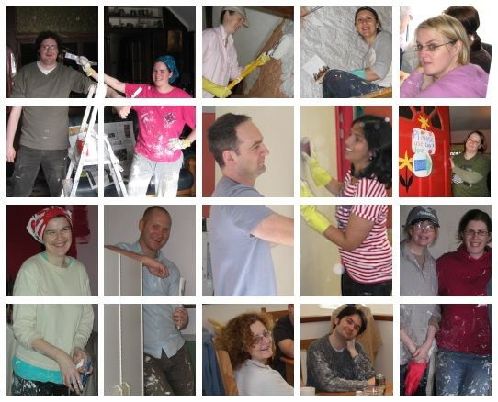

**6. Youth Voices Online**

In March 2021, VSI facilitated an online workshop called ‘Online Youth Voices: How inclusive is your community?’ in collaboration with SCI Hellas in Greece and Liberties College in Dublin. 37 participants attended the online workshop, which created a space for intercultural exchange between young people in Ireland and young people in Greece from migrant or refugee backgrounds.

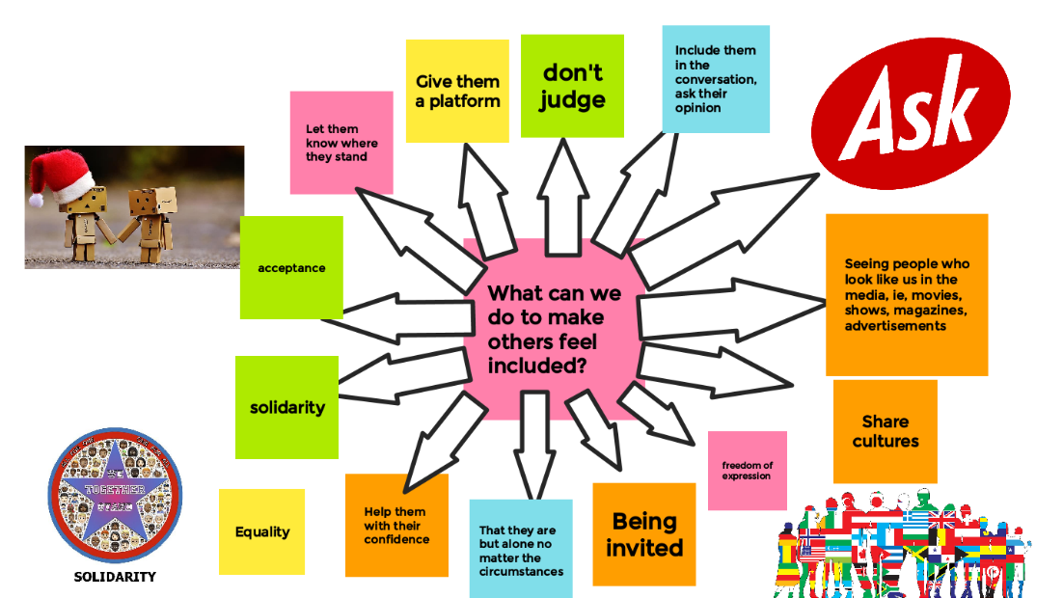

***‘How to make others feel included’ poster created by the workshop participants***

Participants learnt about inclusion, solidarity and intercultural understanding. Participants had a virtual discussion in an online exhibition (you can view the exhibition [here!](https://padlet.com/volunteervsi/6ghze5vbc5wdk8mi)) and created online posters together in small groups, such as the one below. To close the workshop, we celebrated the participants’ contributions by giving them Certificates of Achievement that outlined all the key intercultural competencies they acquired throughout the day.

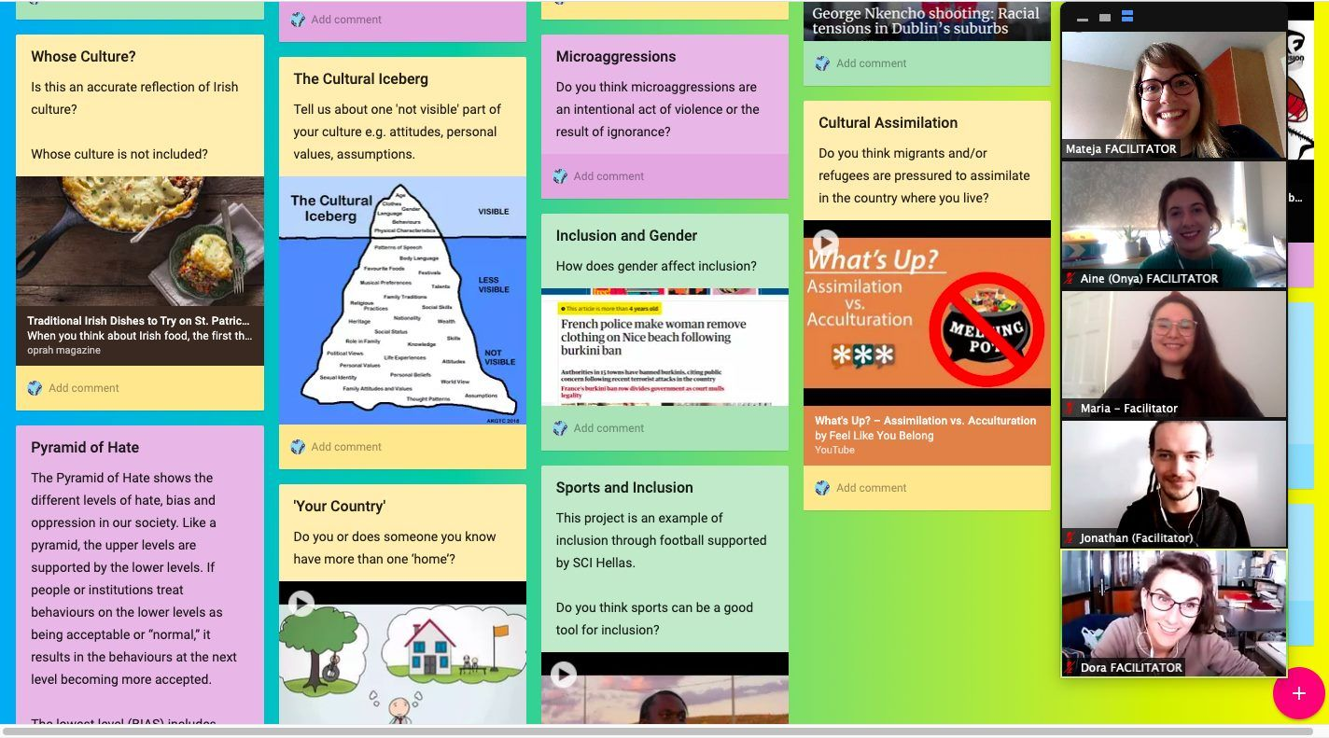

***VSI and SCI Hellas facilitators creating an online exhibition on inclusion***

**7. Youth for Climate Justice**

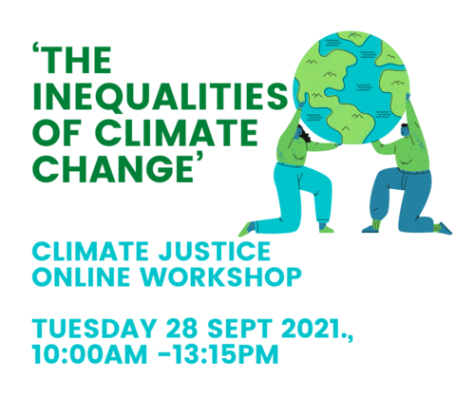In July, VSI ran an online project on climate justice. The project was funded by the Department of Children, Equality, Disability, Integration and Youth under their Youth Climate Justice Fund 2021. Over five days, VSI’s Maria and Aine led interactive and informal workshops with a group of 12 young people from across Ireland. The project was designed to empower young people with the knowledge, skills and confidence to advocate for climate justice.

The workshops encouraged the participants to explore the climate crisis from a human-centred perspective. They explored the unequal causes and consequences of climate change, both nationally and globally, and how solutions for climate change can also address various social justice issues. We finished the week with a session to reflect on and inspire the participants next steps in activism.

To share their learning from the project, participants created a social media awareness raising campaign, with each participant creating a video or series of posts which explored one aspect of climate justice, e.g., climate and classism, education, gender etc. VSI then shared this campaign widely to maximise the impact of our project. You can view the campaign gallery [here](https://padlet.com/placementsvsi/ibnizenj58t2wvdr).

**Project follow-up**

To further inspire the participants to continue their activism after the project, VSI arranged various follow-up opportunities for the participants:

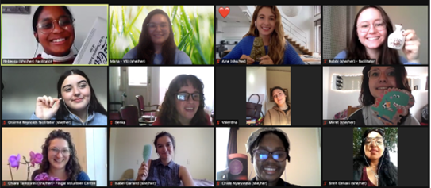First, VSI hosted an info session in collaboration with Leargas on funded ESC and Erasmus+ opportunities for young people and how to use these opportunities to continue climate justice and social justice activism.

To keep the conversation about climate justice going and to involve more people, VSI arranged an online photography exhibition with the theme ‘What Does Climate Justice Mean to You?’.

As our final follow-up, project participants had the opportunity to facilitate their own climate justice workshop with VSI’s support. 3 participants completed facilitation skills training and had various meetings with Maria and Aine to help structure their workshop. The 3-hour workshop was called 'The Inequalities of Climate Change' and 10 international and Irish volunteers attended. The 3 new facilitators gave a short presentation on climate justice and guided the participants through some of their favourite activities from the project, with many lively discussions between activities!

Project participants using their learning to deliver their own climate justice workshop

We were really inspired by all of the hard work and motivation of everyone who participated in our ‘Youth for Climate Justice’ project and want to say another big thank you to you all!

**Participant Experience**

Before VSI, I wasn't sure where to start with climate activism, but now I know... I have gained the confidence I needed to continue on my journey of climate activism! -**Rebecca, ‘Youth for Climate Justice’ project participant**

**Service Civil International (SCI)**

**8. Networking and cooperation**

**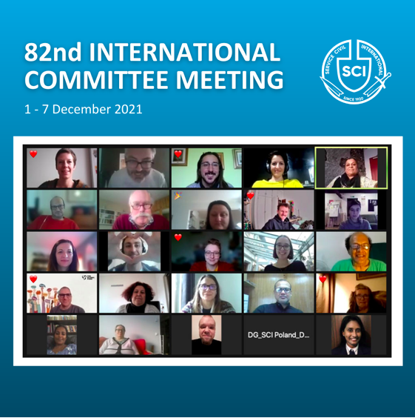**

VSI is the Irish member of SCI (Service Civil Interantional) which is our main link for international cooperation, both at international level and between branches.

Former VSI staff member Tom Ryder attended the International Committee Meeting of SCI in December 2021. Over the week-long event, representatives from the SCI branches met online to reflect on the activities of SCI, take collective decisions for the organisation, and plan ahead.

**Tom says:**

*‘People connected from different time zones, from Australia to Austria and India to Ireland, for 5 days of discussions and voting...Some animated debates took place, showing SCI’s variety of points of view and backgrounds, but always keeping a very respectful tone and collaborative attitude.’*

**SCI Exchange Platform Meeting (EPM)**

The VSI team engaged in a number of online SCI-related international meetings in 2021:

Aine attended the EPM in October, which was held online for the second time and took place over ten days. The EPM is a global meeting of SCI branches, partners, and volunteers, who come together to share best practices and reflect on issues arising in international volunteering. It’s also a great opportunity for members of the SCI community to get to know each other and catch up.

Over various workshops and discussions, the SCI community explored social inclusion, culture, gender, communication strategies, statistics and insurance, and many other topics. As always, it was an enjoyable and inspiring event, and provided plenty of motivation for the year ahead!

***Networking and Cooperation (Continued)***

**Networking In Ireland**

VSI’s new Strategic Plan reaffirms our commitment to working in partnership with organisations which share our aims.

We continue to play an active role in a number of networks. In addition to the support and advocacy provided by the organisations described below, each provides networking events and training that VSI staff and volunteers participated over the year and they are always available at the end of the phone for support and advice.

|  |  |
| --- | --- |
| NYCI Logo - National Youth Council of IrelandThe National Youth Council of Ireland (NYCI) is the representative body for voluntary youth organisations in Ireland and VSI has been a member for many years. NYCI acts as a liaison and support between member organisations and the DCEDIY regarding the Youth Service Grant (YSG). The NYCI was core to setting-up and supporting the DCEDIY’s Shared Services support for small organisations in receipt of the YSG which VSI benefits from in the way of accountancy support and governance training. Helen attends NYCI Heads of Organisations and Specialist Organisations meetings throughout the year. NYCI processes VSI’s Garda Vetting applications for our volunteers working with children and vulnerable adults and also provides support in this area. | |
| Dóchas (@Dochasnetwork) / TwitterVSI has also been a member of Dóchas, the Irish Association for Non-Governmental Development Organisations for many years. VSI is a signatory to the Dóchas Code of Conduct on Images and Messages and we are involved with the Small Member and the Disability & International Development groups. | |
| VSI has been a member of IDEA for many years and in May 2021, VSI became a member of the **IDEA** (the Irish Development Education Association) **Code of Good Practice for Development Education**. Code members commit to strengthening their development education practice through an annual self-assessment process. The VSI team submitted our first self-assessment in July. The self-assessment process was a great opportunity for the VSI staff and Board to discuss and reflect on VSI’s development education work. VSI has a long history of development education, and this is something which we want to continue to grow and strengthen, using the IDEA Code as a framework. |

***Networking and Cooperation (Continued)***

|  |
| --- |
| Comhlámh nurtures, guides and mobilises development workers and volunteers to work for social justice locally and globally. VSI is a signatory to Comhlámh’s Code of Good Practice, a set of standards for Irish Volunteer Sending Agencies facilitating international placements. Over the year VSI staff and volunteers attend the very useful Peer Support Meetings with Comhlámh. Being a signatory to the Code over the years has contributed to VSI’s improved volunteer programmes, services and support that we provide to all our volunteers. |

****VSI is one of 10 organisations in Ireland holding a Quality Label, awarded by Léargas, the national agency managing national and international programmes in youth work, education and training including the European Solidarity Corps programme. A Quality Label is a certification that an organisation is able and willing to carry out high quality solidarity activities in accordance with the principles, objectives and quality standards of the ESC. In addition to managing the programmes, Léargas also provides many networking opportunities with other Quality Label holders and new organisations as well as support and training opportunities.

**VSI Staff collaboration with partners in Ireland**

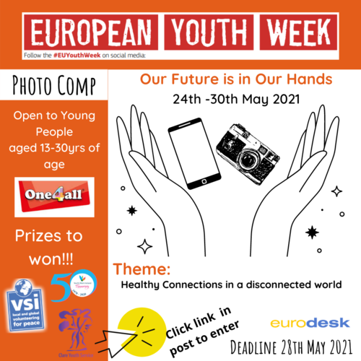**Promoting EU Opportunities with Eurodesk**

Maria was involved as a Eurodesk Network Ambassador and Multiplier. In this role she supported Eurodesk activities and events over the course of the year, in particular for European Youth Week in May, and for Time to Move Week in October, both of which aimed to encourage young people all over Europe to seek out opportunities to work, study, train, or volunteer in Europe. Maria’s work during the year included organising a photography competition which attracted entries from young people all around Ireland, and creating an online informational resource on EU opportunities for young people called ‘Europe from your Fingertips’.

Maria, along with VSI volunteer Amy Collins, was even interviewed for Europe Direct Blanchardstown’s podcast series on Education and Employment Opportunities for young people in the EU!

***Poster for European Youth Week photography contest, organised by Maria***

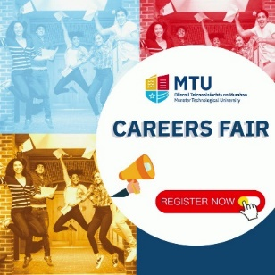

**MTU Careers Fair**

Maria represented VSI at Munster Technological University’s Career Fair in June, where she provided interested young people with information on VSI’s volunteering opportunities via a virtual ‘stall’.

**VSI Board 2021**

**9. Governance**

|  |  |  |  |  |  |
| --- | --- | --- | --- | --- | --- |
| Claire Devlin VSI board photo |  |  | Infinity_264 (1) (1) | Pearl Clarke |  |
| **Claire Devlin** | **Dervla King** | **Máille Brady-Bates** | **Liam Keenan** | **Pearl Clarke** | **Robin Hanan (Chair)** |

**Jason Campbell and Ian Carter resigned in January 2021. Pearl Clarke resigned in October 2021.**

**The Board met** 5 times during the year. **The Company Secretary** was Helen Walmsley.

**Board members are not remunerated** and gain no private benefit from their role.

**The Finance Sub-Committee of the Board** was composed of Pearl Clarke, Robin Hanan and Helen Walmsley, with Del Thorogood in attendance

**In 2021, The Board and staff started to implement the new Strategic Plan, completed at the start of the year.** and prepared for full compliance with the new Charities Governance Code which will both be completed in 2021.

**VSI AGM 2021**

VSI’s 2021 AGM was held in June. It was the second online VSI AGM and was chaired by Robin, all the way from a café in Greece! The AGM was a great opportunity to see some familiar faces and to share VSI's activities and governance with our members.

**Governance**

**The Governance Policy and Compliance Committee** was chaired by Claire Devlin and included Máille Brady-Bates, Robin Hanan and Helen Walmsley. The committee is grateful for the pro-bono support of Arthur Cox Ltd in reviewing and developing policies.

VSI is now fully compliant with the Charities Regulator’s Governance Code.

**10. Staff**

|  |  |  |  |
| --- | --- | --- | --- |
| **Maria Conte**, (ESC, Communications and Marketing Officer until November 2021) | **Mateja Jakšić** (Volunteer Programme Coordinator until May 2021) | **Eiméar Savage (**ESC, Programme Officer from November 2021 |  |
|  | | Picture 1 | **Del Thorogood** Admin and Finance Officer |
| **Helen Walmsley** (CEO) | **Aine Boyle(** ESC Programme Officer until November 2021 then Programmes Officer) | **Nicolas de Wergifosse** (ESC Communications and Marketing Officer from November 2021) |  |

**Thank You Mateja**

****Mateja started in VSI as a European Voluntary Service (EVS) volunteer in 2016 and then became a valued staff member from 2017. Her multiple skills, energy and enthusiasm were much appreciated in VSI, at all times efficient, professional and innovative. In addition to bringing her skills, energy and enthusiasm to all areas of VSI's work, especially with our volunteers on all programmes, Mateja had a particular impact on specific projects including the Step-Up ESC project, CAT4YE training seminar in Greece, the children's summer camp in Mosney, the Eurodesk network and our projects in Killarney National Park. Mateja is a pleasure to work with, always cheerful and warm and with a wonderful sense of humour. Mateja made many lasting friendships in VSI and SCI and as we all know, you never really leave VSI! Thank you Mateja!

*Mateja with VSI volunteer friends in Killarney*

**Staff Training**

VSI staff participated in a number of external training opportunities for professional development: Aine attended the SCI Placement Officer Training (POT), which brought together placement officers from SCI branches and partners worldwide to learn the ins and outs of placing volunteers on IVPs, while Maria attended The Wheel’s ‘The Art of Storytelling’ Series to support her communications work for VSI. Both Aine and Maria received facilitation skills training to support their work in delivering Global Citizenship Education workshops for VSI.

To brush up on their own Global Citizenship knowledge, Aine and Maria completed the ‘Learners as Leaders’ programme on advocating for the SDGs with AONTAS and Development Perspectives, Eimear and Nick completed STAND’s Global Issues Autumn course, and Aine participated in the international seminar ‘Develop or Self-Develop’; which explored the colonial context of international volunteering.

Helen completed the Common Purpose Programme for Senior Leaders, this in-depth course ran over three months and included modules on Personal Agility, Leading People and Transforming Systems. Helen participated in the Shared Services initiative (from the Wheel and NYCI, funded by the DCEDIY) training workshops on topics such as Risk Management, Strategic Leadership and Good Communication as well as a number of short trainings over the year, including Fundraising with Comhlámh’s Training Links Network and Staff Wellbeing through the Carmichael.

**11. Funding and Finances**

|  |  |
| --- | --- |
| **VSI would like to thank our funders, without whom our activities would not have been possible.:**   * The Department of Children, Equality, Disability, Integration and Youth (DCEDIY) * The European Commission (through the European Solidarity Corps (ESC) programme and Léargas) * Health Service Executive * Private donors * Members | YCJF Branding_FullColour_NoDCEDIY |

**VSI Income 2021**

**Get Involved in VSI!**

|  |  |
| --- | --- |
| **Volunteer** Website banner IVP  Are you interested making a difference with your free time and finding a cost-effective way to explore Europe? VSI have resumed sending in-person volunteers on short-term projects in Europe! Our dedicated staff have put together a list of projects which focus on our core values including solidarity, environmentalism and human rights!  **View our regularly-updated list of projects**[**here!**](https://www.vsi.ie/volunteer/ivp/vsi-short-term-international-volunteering-database)  **Click**[**here**](https://www.vsi.ie/volunteer/ivp.html)**to learn more about this programme and the application process.** | **Membership** **Voluntary Service International** is a membership organisation and we rely on the enthusiasm, dynamism and experience of members to ensure that we remain a vibrant and relevant organisation. Many members are active in supporting the various programmes, projects and events which VSI organises each year. Join us and get involved! Voluntary Service International is open to all who support our aims.  **Annual Membership**   * waged individuals: €40 * unwaged individuals: €20 * asylum seekers/refugees: €2   **Life Membership:** €300 To become a member, you can complete the online membership form [****here****](https://forms.gle/9TBU2VftBuQ11xPt7) ****and**** pay your membership fee [online here](http://www.vsi.ie/payments/) through Pay Pal; or contact us at [info@vsi.ie](mailto:info@vsi.ie) for other payment optionsBenefits of membership  * Access to a wide range of local, national and international volunteering opportunities * Regular membership updates and volunteering news through bulletins and facebook * Opportunities to get involved with ongoing projects and events in Ireland * Regular international bulletins from SCI * Invites to training and seminar opportunities in Ireland and abroad * Invitation to our AGM and the opportunity to contribute your ideas to VSI   VSI hold an **Annual General Meeting (AGM)** to which all members are invited. The AGM elects a National Committee (Board) which manages the affairs of VSI until the following years AGM. |

**Developing the Plan**

**Annex A: VSI Strategic Plan 2021-2025**

In 2020 and 2021, VSI carried out a thorough review of our work and developed a new strategic plan for 2021-2025. Sandra Velthuis consulted stakeholders through a survey and a series of interviews. She then facilitated two seminars, in Spring 2021, to develop the strategic plan, involving Board members, staff and some volunteer members.

The plan, below, was finalised and approved by the Board in June 2021 and presented to the AGM in July.

**Introduction**

Voluntary Service International (VSI) is the Irish branch of Service Civil International (SCI), a worldwide peace movement that was founded after the First World War. We are a volunteer-based movement, founded in 1965 and headquartered in Dublin.

For over 55 years we have promoted peace, social justice and sustainable development at home and abroad. During that time walls have fallen, borders have moved and the challenges facing us have changed. While there have been significant improvements during this time, many of the old problems remain (e.g. conflict, human rights abuses) alongside the emergence of new problems (e.g. climate change, growing inequality).

These challenges are large and multifaceted but we at VSI believe that we can play a part in addressing them. At the heart of many of these problems lies a lack of understanding, of people, their backgrounds, their cultures, their own day-to-day challenges. There is a lack of understanding of the environment, its importance, its fragility, our impact on it and of the interdependence of all of these things.

The tool we have chosen to help combat this is a simple one but we know through experience that it is a powerful one: **volunteering**. By bringing together people from across the globe to participate in values-based volunteering, we aim to increase awareness and understanding of the people, the societies and the environment around us.  This deeper understanding will contribute to a global and local society which is more open-minded, aware and responsible for its own behavior and actions. We are able to do this with the help of our network partner organisations at home and abroad, enabling volunteering experiences that promote peace, social justice and sustainable development.

In 55 years we have achieved a lot as an organisation. We recognise that over this time the world has changed and that we, as VSI, need to adapt to this and the new challenges it presents. This strategic plan represents our vision and intent for how we plan to meet those challenges.

**VSI Vision and Mission**

Although our plans and objectives will change from time to time, our core beliefs and work remain the same.

|  |  |  |
| --- | --- | --- |
| **Our vision** |  | **Our mission** |
| is a world of peace, social justice and sustainable development, where all people live together with mutual respect. |  | is to promote a culture of peace, social justice and sustainable development by organizing and supporting volunteering projects, both in Ireland and internationally. |

***VSI Strategic Plan 2021-2025 (Continued)***

***VSI Strategic Plan 2021-2025 (Continued)***

**Our Values**

Volunteering is at the heart of VSI’s work. We support engagement, without material reward, that benefits society and aims to achieve positive social change. This is guided at all times by our core values. Every voluntary project, meeting, exchange or training reflects these values:

* **Non-violence -** choosing peaceful resistance and conflict resolution without recourse to violence as a principle and a method
* **Human Rights -** respect for individuals as stated in the Universal Declaration of Human Rights
* **Solidarity -** international solidarity for a more just and equitable world, and solidarity between all human beings
* **Respect for the Environment -** and the ecosystems of which we are a part and upon which we are dependent
* **Inclusion -** being open and inclusive of all individuals without discrimination
* **Empowerment -** providing people with knowledge and tools to understand and act to transform the social, cultural and economic structures that affect their lives at all levels
* **Co-operation -** with local communities as well as other local, national and international partners to strengthen the positive potential within civil society as a whole

**Our Partnership Model**

VSI is part of an international movement of different peoples and bodies working together to create a culture of peace.

* **Volunteers:** Volunteers are the lifeblood of our organisation. They enable our mission and values and carry it with them during and after their volunteering experiences with VSI, bringing it into their communities and their day-to-day lives.
* **Partners :** VSI is a branch of Service Civil International (SCI), which consists of 41 branches and groups all over the world. These work independently in their own country on the exchange of volunteers and coordination of projects, working towards SCI’s mission of a culture of peace. This connects us to partners and communities across the world. VSI also cooperates with partner organisations all over Ireland. These partner organisations are independent but like-minded organisations that also run voluntary projects. VSI and partners cooperate in many ways, but mainly through volunteer exchanges and projects.
* **Other NGOs, Government bodies, donors, and stakeholders :** Beyond our direct partners there is a wider ecosystem in which VSI interacts and works to further its mission. While we are not a direct campaigning body, we do advocate in relevant forums involving other NGOs and government bodies to promote a culture of peace, social justice and sustainable development.

***VSI Strategic Plan 2021-2025 (Continued)***

**Our Goals**

**Goal 1 - Re-emphasise the value of volunteering for peace**

Working for peace is a continuous process, and while everyone desires to live in a peaceful society, living and building peace requires, amongst others, empathy, understanding and proactivity. Volunteering helps build all of these, fostering habits that can have a positive impact beyond individual volunteering projects and across the lifetime of a volunteer.

Key to enabling this is identifying and organising quality volunteering opportunities that reinforce the values we stand for. We will provide a structure and a space in which volunteers can learn and discuss what peace, social justice and sustainable development are, why they’re important, and their role in nurturing and strengthening it in their communities.

**Objective 1.1 Reaffirm our commitment to high-quality projects that are aligned with our values**

VSI has a strong commitment to implementing high-quality volunteering opportunities and projects. This means understanding and explaining the reasons behind the implementation of the projects and also, their intended impact on society, people, and the environment. Activities, including the ‘workcamp’ model of volunteering, should be meaningful with a focus on a broad understanding of peace including intercultural dialogue, solidarity, and non-violent communication using different non-formal education methods.

**Actions:**

* Review current projects and partnerships and seek additional partners, as necessary, who have the capacity to ensure quality short- and long-term volunteering experiences that reflect our values.
* Offer volunteering opportunities that allow engagement with the major challenges of our time, including global and local inequality, climate change and environmental degradation.
* Support individuals throughout their volunteering journeys, incorporating global citizenship education opportunities at every stage. This includes undertaking additional activities that encourage volunteers to remain engaged after a placement.
* Improve training resources on VSI programmes with a focus on user-friendly design and accessibility, including online tools and webinars.

**Objective 1.2 Strengthen our cooperation with SCI, its members and other international partners**

One of VSI’s greatest strengths is its network of partners internationally. Reinforcing those connections and building new ones will empower us to create a greater number of higher quality volunteering experiences, providing opportunities for mutual learning and solidarity, amplifying our impact and that of our partners.

**Actions:**

* Cultivate closer ties to SCI, joining in campaigns and supporting initiatives that further our shared goals, e.g. co-investment in the SCI project and search database
* Build projects and partnerships with SCI member organizations that share our focus on high quality engagement
* Deepen our engagement with members, volunteers and allies in Northern Ireland with the aim of increasing the number of cross-border volunteering opportunities

***VSI Strategic Plan 2021-2025 (Continued)***

**Goal 2 - Empower people across Ireland and around the world to experience volunteering for peace**

To achieve our mission we must increase the impact of our practice of volunteering for peace at home and abroad. This will include involving more and more diverse volunteers, as resources can be sourced, and maximising the impact of this experience in broader communities. Key to this will be building greater awareness of VSI and our model. We will work on increasing the inclusivity of our activities, improving accessibility for excluded members of society. This includes ensuring access to marginalised populations and difficult to reach groups.

**Objective 2.1 Increase participation in volunteering by creating greater awareness of the projects we facilitate and the importance of our mission**

We must continue to update how we engage with the public in the modern age. This will involve examining our communication methods and online platforms and updating them to better align with our target audience, allowing us to bring our vision and mission to more people.

**Actions:**

* Launch our new website
* Devote more staffing and resources to marketing, communications, and awareness, generating content for our website, social media, and email outreach
* Establish clear, structured marketing and awareness plan leveraging both traditional and modern media and platforms and building on partnerships with like-minded organisations

**Objective 2.2 Broaden inclusivity of opportunities**

Inclusion is a core value of VSI and has been ever-present in how we operate as an organization since our inception. We will continue to reassert this value by working to expand the number of opportunities to those with fewer opportunities.

**Actions:**

* Identify and partner with local groups and communities of interest facing disadvantage across Ireland and work to facilitate and grow their participation in VSI projects
* Develop joint projects with these communities drawing on the local knowledge of community groups and the international connections and experience of volunteering in VSI
* Secure funding linked to this strand of our work

**Goal 3 - Strengthen and grow VSI**

In order to achieve our goals we must continue to build on our strengths while also investing in our own development as an organisation. To support our ambitious goals, we need to diversify and expand our funding, providing a stable base on which to grow. We will increase our investment on building strong, long-term relationships with the one group who are central to everything that we do: our volunteers. Investments in governance will continue, maintaining VSI’s strong reputation and further improving our effectiveness.

**Objective 3.1 Diversify and grow funding**

Sustainable and diversified funding is critical to ensuring the delivery of this plan.

**Actions:**

* Develop a new funding and resourcing plan to reflect the priorities of this Strategic Plan
* Identify new sources of funding alongside existing sources

***VSI Strategic Plan 2021-2025 (Continued)***

**Objective 3.2 Establish a vibrant volunteer community**

Volunteers are the lifeblood of VSI. Past volunteers have built a lifelong relationship with VSI and are now facilitating the next generation of volunteers to learn about the benefits and impact of volunteering for peace. Changing social relations, the rise of social media, and the growth of commercially-oriented ‘voluntourism’ mean that we must now work differently to re-establish a vibrant volunteer community.

**Actions:**

* Make building a connection with fellow volunteers and VSI pre and post-project a fundamental part of the volunteer experience
* Support regular social and networking activities, offline and online
* Establish online communities with partner organisations at home and abroad

**Objective 3.3 Establish and embrace governance best practices**

Continue investment in best practices in governance, risk management and financial controls, including compliance with the Charities Governance Code.

**Actions:**

* Ensure full compliance with the Charities Governance Code,  the Comhlámh Code of Good Practice for Volunteer Sending Organisations, the Dochas Code of Practice on Images and Messages, and the IDEA Code of Good Practice for Development Education.
* Ensure that our Governance structures, including our Board, are clear in their areas of responsibility, include the skills needed to carry out their functions and are adequately resourced and supported
* Ensure best practice as an employer, upholding the rights of employees in a safe and supportive work environment

**Objective 3.4 Ensure effective delivery of this Plan**

No plan can be successful without effective monitoring and evaluation of progress versus the agreed goals. To enable our success, we will carry out regular reviews of our progress against the Strategic Plan at a Board level and as part of our AGM. As needed, we will revise our plan, with a full redevelopment of the plan in 2025.

**Potential Actions:**

* Develop Annual Action Plans to guide the achievement of the Strategic Plan, to be adopted by the Board before the start of the year;
* Develop a monitoring and evaluation framework with clear indicators to track progress towards the achievement of annual and strategic plan objectives
* Progress check-ins vs. our goals will be conducted and documented as part of every second Board meeting with updates from the CEO on each goal.
* Annual status updates will be provided at the AGM, along with any revisions required to the Strategic Plan