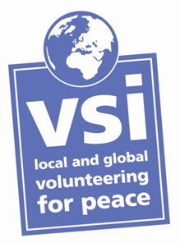
Would you like to volunteer as an assistant for one week in Slovenia, with a Voluntary Service International volunteer who is a wheelchair user?
We are looking for a male volunteer to assist one of our volunteers on a project in Slovenia from 28 August to 5 September 2014. The project is at a holiday centre with the national Slovenian association for paraplegics and tetraplegics, more details below.

The work:
VSI’s volunteer has a disability and uses a wheelchair, he is forty-one years old. The tasks for the role include assistance with showering and dressing and other personal care requirements (which don’t entail medical knowledge). There will be two main parts of the day where assistance is required, in the morning getting ready for the day and in the evening getting ready for bed or going out. The wheelchair is manual so pushing the chair when out and about will be needed. Assistance will also be needed with luggage on the return journey from Dublin airport to Lubljana. The volunteer will also work with the volunteer group on the work of the project in the centre, see project description below but will have free time in lieu for the personal assistant work and will not work more than 7 hours per day.

Experience and skills required:
Experience in personal assistance work would be an advantage but is not essential. The personal assistant (PA) volunteer doesn’t need any medical knowledge or skills but will need to be ready to assist in whatever way is necessary and must be flexible. The PA volunteer will meet with the volunteer beforehand and will be given all the info needed.

Costs:
This is an unpaid volunteer position but there are no project or travel costs for the PA volunteer; travel, food and accommodation are provided free. Insurance cover during the project is also provided. The PA volunteer will just need spending money while away.
This is a great opportunity to take part in an international volunteer project, meet international volunteers, learn about disability issues cross-culturally and to gain an insight to Slovenian culture.
If you are interested in this role please contact Helen in VSI with a brief CV and a motivation letter or with any questions: helen@vsi.ie
Once selected, we will request Garda Vetting and seek references from the volunteer.

Application deadline: 27 June 2014

Voluntary Service International (VSI) is the Irish branch of Service Civil International, a worldwide peace movement that began in 1920. We work to promote peace, social justice, sustainable development and intercultural understanding through volunteering abroad and in Ireland.

VSI is a registered charity: CHY 9220. VSI is registered as a limited company, no. 140520, having no share capital.
www.vsi.ie

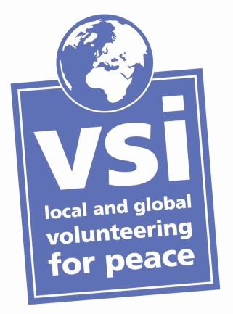
Volunteer Project description from our host organisation in Slovenia:
11th Workcamp of Young Paraplegics and Tetraplegics

Code: SI-SCI 9.11
Country: Slovenia
Start Date: 28 Aug - 5 Sep 2014
Type of work: Working with people with disabilities
Total number of volunteers: 6
Language: English

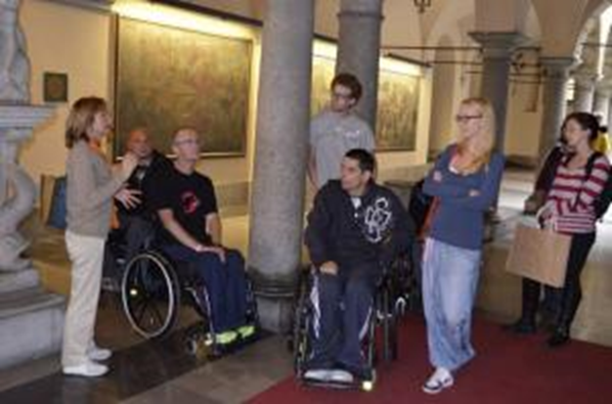
Description: Our association aims to assist paraplegics and tetraplegics after the end of their rehabilitation and offers them a professional network of activities that enable them to settle down and reintegrate to their local environment. We aim to equip them with tools so they can start independent and active lives. We offer them transportation to schools, health centres etc. and organize different sport and educational activities. Every year we also organize a summer camp for the members of our association with the participation of foreign volunteers.

Type of Work: The volunteers will help paraplegics and tetraplegics (the members of our association). Their main job will be preparing the meals and taking care of house cleanliness. Also they will talk with members and spend time together, play chess and cards. The volunteers will not need to help our members in personal care. During the project we will organize some tours around Bela Krajina and the coastal region of Slovenia, which is very beautiful.
Study Theme: The volunteers will learn about the day to day life of our members.
Accommodation: The volunteers will be accommodated in a house together with our members (single sex rooms).
Language: We will use Slovenian and English language (knowledge of Slovenian is not necessary!).
Approximate Location: The project will take place on two locations, Semic and Pacug. The closest terminal is Brnik in Ljubljana. The association will take care of all the transport during the project for wheelchair users and their assistants. Volunteers will be met by us on their arrival.

