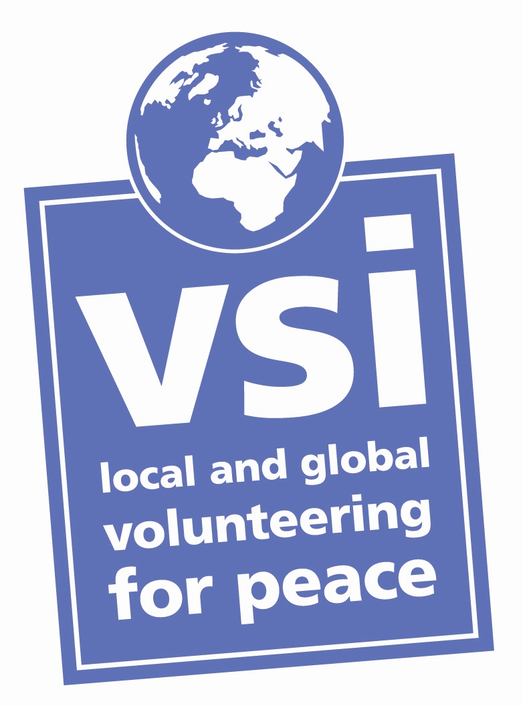
Project Coordinators Application Form 2019

Please answer all the questions in this form fully and return the completed form to Mateja in VSI: mateja@vsi.ie

- Personal details and contact info

Please reply the following questions.
Family name

First name

Gender

Date and place of birth

Nationality

Mobile phone number

Landline phone number

Email

Home Address

Emergency Contact name and telephone number

- Education and training
Please copy the table for additional entries.
Please list your education and training history from when you left school.
College/university/training body
Dates attended
Main subjects studied
Qualification

Please list your education and training history from when you left school.
College/university/training body

Dates attended
Main subjects studied
Qualification

- Employment and volunteering
Please copy the table for additional entries.
Please list all your employment and volunteering experience.
Organisation name and location

Nature of your involvement in the organisation  Please double-click to tick one box | Employee  Volunteer  Intern
Dates of service

Brief description of your role and main responsibilities

Please list all your employment and volunteering experience.
Organisation name and location

Nature of your involvement in the organisation  Please double-click to tick one box | Employee  Volunteer  Intern
Dates of service

Brief description of your role and main responsibilities

- Languages
Please copy the rows for additional entries.
Language | Level (fluent, good, basic)

- About you
- Do you have any coordination or leadership experience?

- What would you like to gain from being a Project Coordinator?

- What skills or qualities would you bring to the post of Project Coordinator?

- What are your hobbies and interests? (150 words maximum)

- Is there anything else you would like to tell us about yourself? (150 words maximum)

- Health: Do you have any significant health problems that would affect your participation in the volunteer project? Do you take any regular medication? (Volunteers have a personal responsibility to ensure that they are in good health, fit for travel, and have received all vaccinations appropriate for their destination.)

- Which project(s) are you interested in coordinating in 2019? (Please highlight one or more projects. Click on the project for a project description.)
Killarney National Park project dates:
- 1st project: 16.06. - 29.06.
- 2nd project: 07.07. - 20.07.
- 3rd project: 28.07. - 10.08.
- 4th project: 11.08. - 24.08.

If you have any questions, please email mateja@vsi.ie or phone 018551011

Thanks for completing the form!

